**Project Design Phase-I Solution Architecture**

|  |  |
| --- | --- |
| TEAM LEAD | S.SATHISH |
| NM ID | D3AB4E60998F2BBA802428A0FF7D9B00 |
| PROJECT NAME | Creating a landing page in Hubspot |

**Solution Architecture:**

Solution architecture is a complex process – with many sub-processes – that bridges the gap between business problems and technology solutions. Its goals are to:

● Find the best tech solution to solve existing business problems.

● Describe the structure, characteristics, behaviour, and other aspects of the software to project stakeholders.

● Define features, development phases, and solution requirements.

● Provide specifications according to which the solution is defined, managed, and delivered.

**Solution Architecture for landing page in HubSpot**

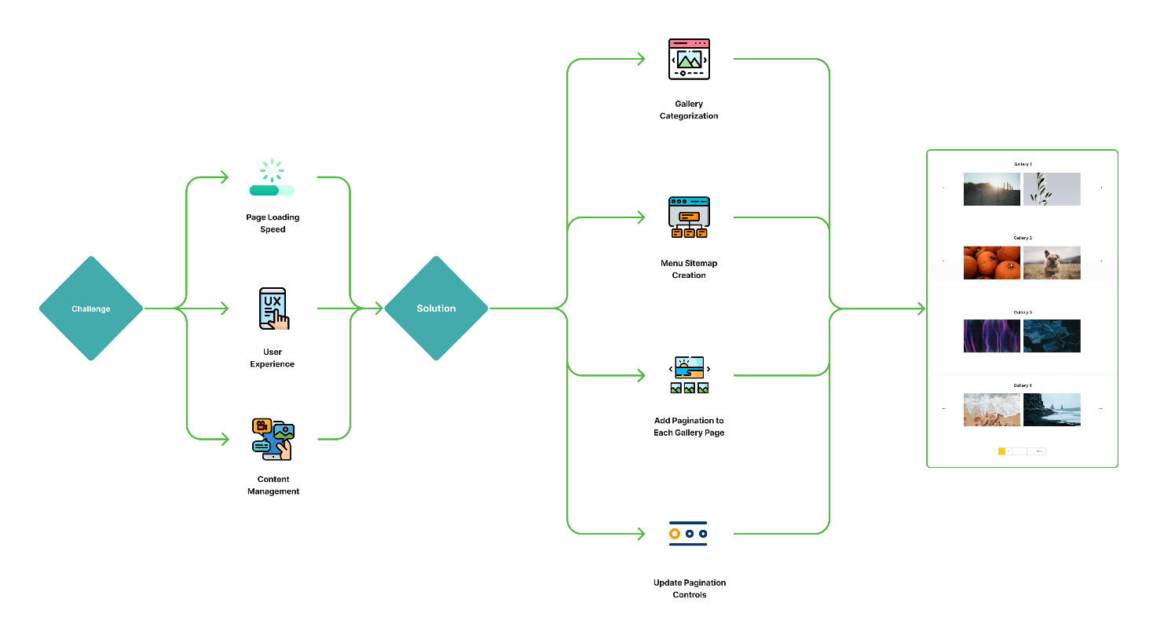

**Flow of the Project:**

Creating a landing page in HubSpot involves designing and implementing a web page that is specifically optimized for lead generation and conversion. Here's a high-level solution architecture for creating a landing page in HubSpot:

**1. **Planning and Strategy**:**

- Define your target audience and specific goals for the landing page.

- Determine the key message, value proposition, and call-to-action (CTA) that you want to convey on the landing page.

**2. **Content Creation**:**

- Write compelling and concise copy that resonates with your target audience.

- Create eye-catching visuals, including images, graphics, and videos, to support your message.

- Develop a lead magnet, such as an ebook, whitepaper, or webinar, that you can offer in exchange for visitor information.

**3. **HubSpot Account Setup**:**

- If you haven't already, sign up for a HubSpot account and set up your basic account settings.

**4. **Landing Page Creation**:**

- In HubSpot, navigate to the "Marketing" or "Website" section and choose the "Landing Pages" tool.

- Create a new landing page and choose a template that suits your needs. HubSpot provides various customizable templates.

- Use the drag-and-drop editor to design the page, add content, and include your CTA button.

- Ensure that the page is mobile-responsive for a seamless user experience on different devices.

**5. **Form Integration**:**

- Include a lead capture form on the landing page using HubSpot's form builder.

- Specify the information you want to collect (e.g., name, email, company), keeping it as minimal as possible while still achieving your goals.

**6. **CTA and Conversion Tracking**:**

- Create a compelling CTA button that stands out and is linked to your form.

- Implement conversion tracking in HubSpot to monitor the page's performance and measure conversion rates.

**7. **SEO Optimization**:**

- Optimize the landing page for search engines by including relevant keywords in the page title, meta description, and header tags.

- Use a descriptive URL structure and ensure fast page loading times.

**8. **A/B Testing**:**

- Consider setting up A/B tests to experiment with different elements on the landing page, such as CTA text, colors, or images, to optimize conversion rates.

**9. **Thank-You Page**:**

- Create a thank-you page that visitors see after submitting the form. This is where you can provide the lead magnet or additional information.

- Use HubSpot to track leads' progress and engagement.

**10. **CTA Promotion**:**

- Promote the landing page and CTA through various channels, including email marketing, social media, and your website.

- Consider using HubSpot's email marketing and automation tools for targeted outreach.

**11. **Analytics and Reporting**:**

- Regularly monitor the landing page's performance through HubSpot's analytics tools.

- Adjust your strategy and page elements based on the data you collect to improve conversion rates.

**12. **Optimization and Iteration**:**

- Continuously refine your landing page based on user behaviour and performance data.

- Run tests and experiments to improve conversion rates over time.

**13. **Compliance and Privacy**:**

- Ensure that your landing page complies with data protection regulations such as GDPR and CCPA. Include a privacy policy and opt-in consent where necessary.

By following this solution architecture, you can create an effective landing page in HubSpot to capture leads and drive conversions for your marketing campaigns. HubSpot provides numerous features and tools to support this process and help you analyse and optimize your landing page's performance.